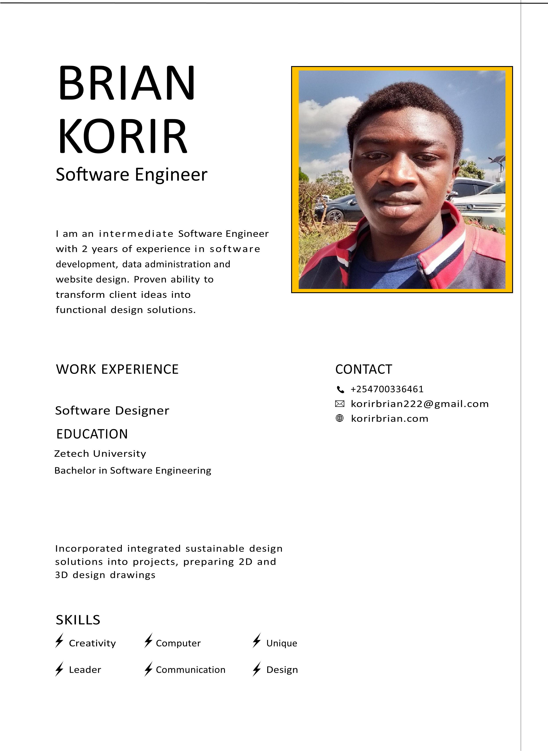

COVER LETTER BY

# BRIAN KORIR

## Software Engineer

### DEAR MR. ANDREW

I am writing a letter of interest in regards to the position in your company. Your company is known for its innovation, professionalism, and results-driven marketing strategy, which is why I am certain I would make a valuable addition to your team. I would be interested in learning more about the company and available opportunities, so I have enclosed my resume for your consideration.

I am confident that my experience in this field will be an asset to your company. As you will see on my resume, I have a proven record of achievements, which will allow me to make major contributions to your company.

I look forward to speaking with you to discuss how my experience and abilities match your needs. I will call you on the day of the week to see what day and time fit your busy schedule. Don’t hesitate to contact me at your phone number or contact me by email at your email address should you have any questions. I look forward to speaking with you.